B1

Evidence & Causes 2020

Earth’s surface

is emitted by

warms it

Infrared radiation

surface and

by Earth’s

is absorbed

Some radiation

Agency.

from US Environmental Protection

Eart

h‘s Su

rfac

e

lower atmosphere.

warmer. Image based on a ﬁgure

surface and the

surface and lower atmosphere even

Atmosphere

this is to warm Earth’s

enhances the effect, making Earth’s

by the atmosphere. The effect of

house gases to the atmosphere

atmosphere

gases and re-emitted in all directions

sphere warm. Adding more green-

Earth and the

Some is absorbed by greenhouse

is reﬂected by

Earth’s surface and lower atmo-

passes through the atmosphere.

Some solar radiation

Some of the infrared radiation

(including downwards), keeping

energy and emit it in all directions

and nitrous oxide, absorb heat

THE GREENHOUSE EFFECT

vapour, carbon dioxide, methane,

the atmosphere, including water

Greenhouse gases in

figure B1.

less than the energy entering, Earth warms until a new balance is established.

even more effective at preventing heat from escaping into space. When the energy leaving is

have evolved on our planet. Adding more greenhouse gases to the atmosphere makes it

. Without this greenhouse effect, life as we know it could not

[Figure B1]

atmosphere warm

emit heat energy in all directions (including downwards), keeping Earth’s surface and lower

and nitrous oxide, act to make the surface much warmer than this because they absorb and

Greenhouse gases in the atmosphere, including water vapour, carbon dioxide, methane,

space, Earth’s average surface temperature would be tens of degrees colder than today.

If all heat energy emitted from the surface passed through the atmosphere directly into

in the output of energy from the Sun will affect this balance directly.

balance of incoming and outgoing energy will affect the climate. For example, small changes

absorbs and re-radiates heat, some of which escapes to space. Any disturbance to this

solar energy is re-emitted as heat (longwave or infrared radiation). The atmosphere in turn

clouds, and the rest is absorbed by the surface and the atmosphere. Much of this absorbed

sunlight is reﬂected directly back into space, especially by bright surfaces such as ice and

The Sun serves as the primary energy source for Earth’s climate. Some of the incoming

Greenhouse gases affect Earth’s energy balance and climate.

Climate Change

The Basics of

Q& A n



atmospheric CO

since 1958 from

2

the Mauna Loa Observatory in

Hawaii (black) and from the South

Pole (red) show a steady annual

increase in atmospheric CO

2

concentration. The measurements

are made at remote places like

these because they are not greatly

inﬂuenced by local processes, so

therefore they are representative

of the background atmosphere.

The small up-and-down saw-tooth

pattern reﬂects seasonal changes

in the release and uptake of CO

by

2

plants.Source: Scripps CO

Program

2

Year

Measurements of

Figure B.

2

1

that is, for every million molecules in the air, 316 of them were CO

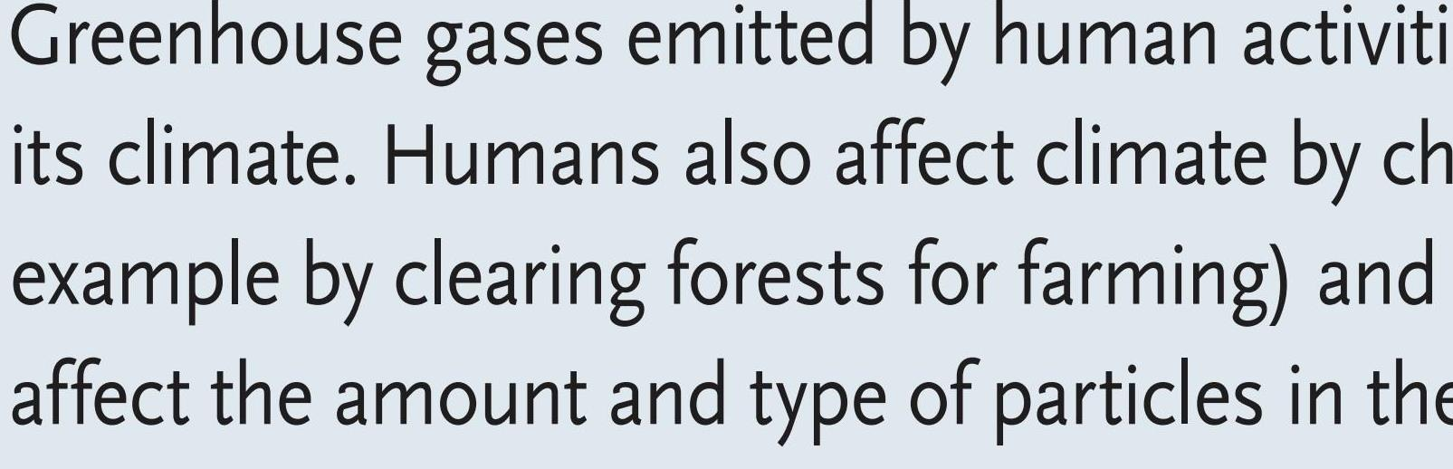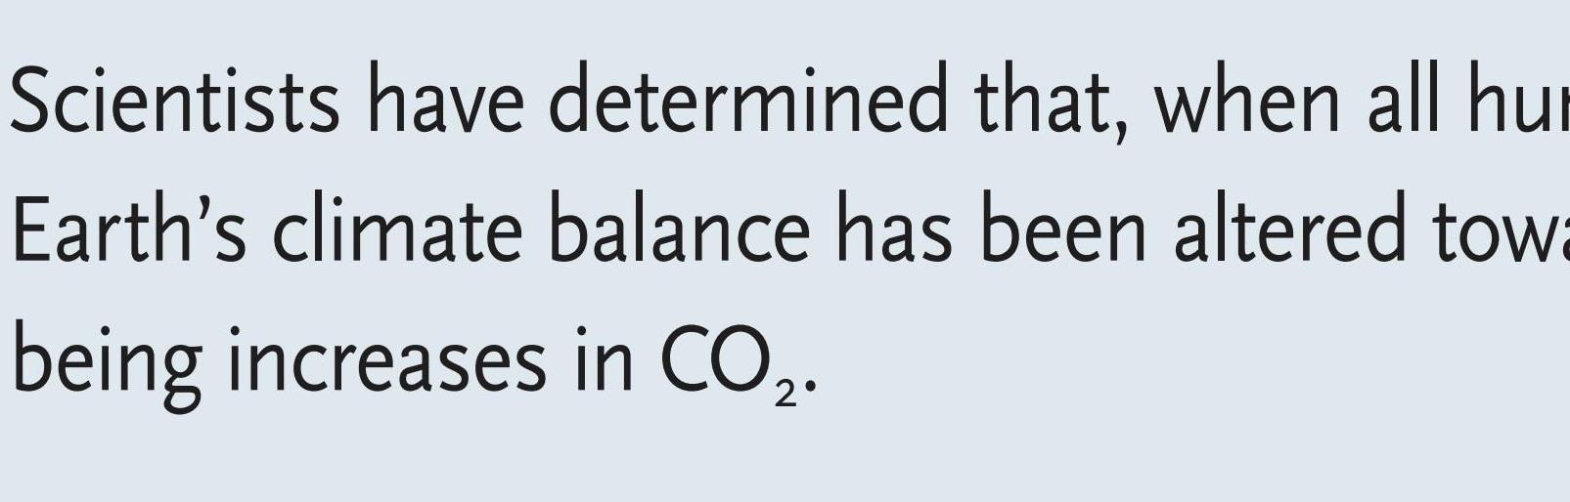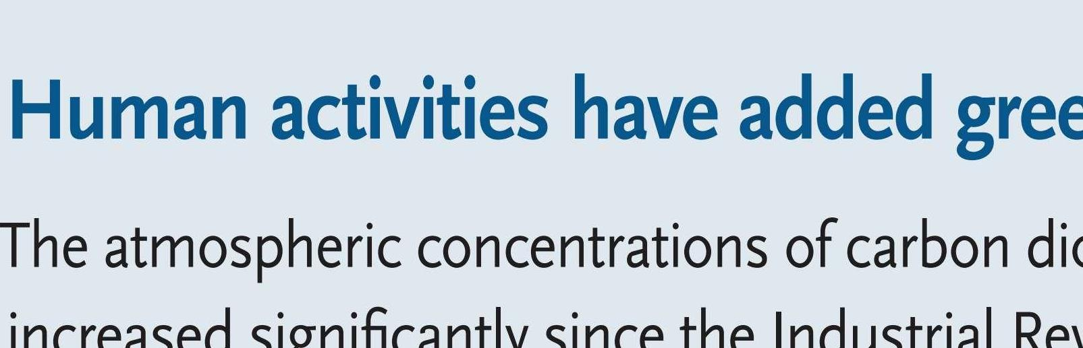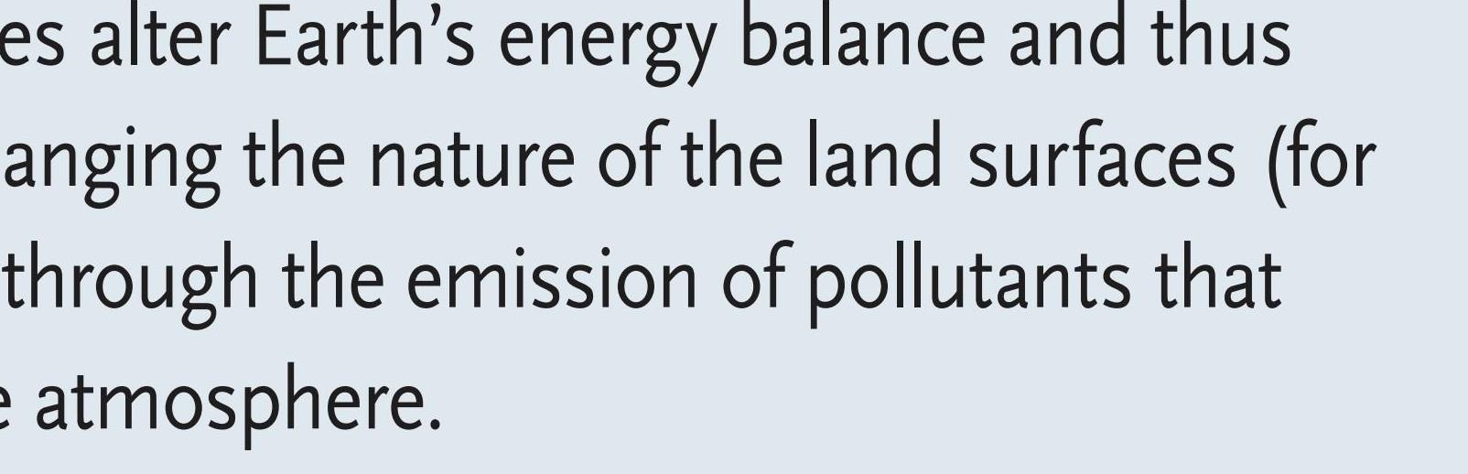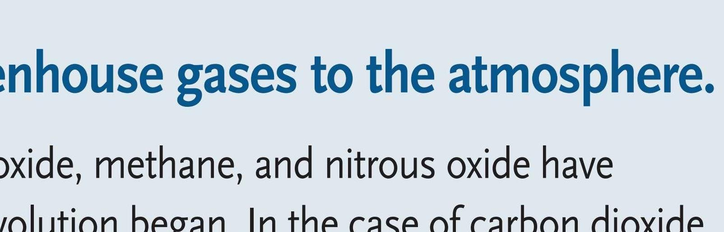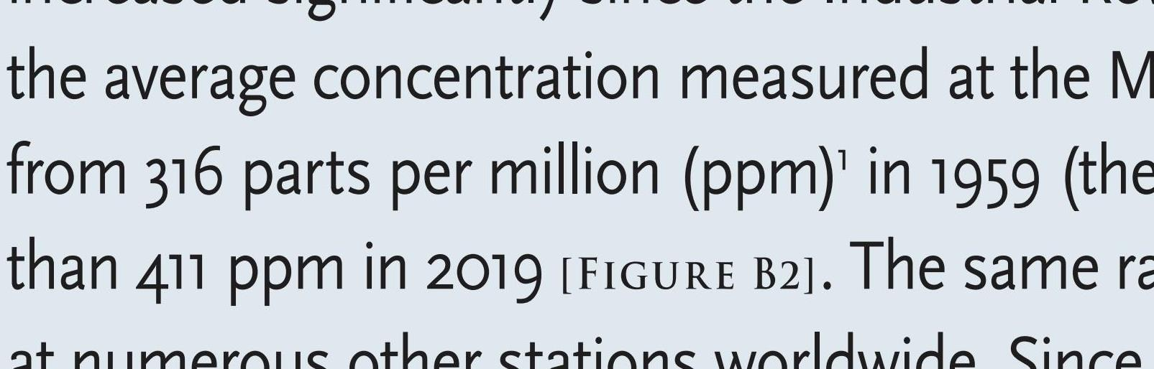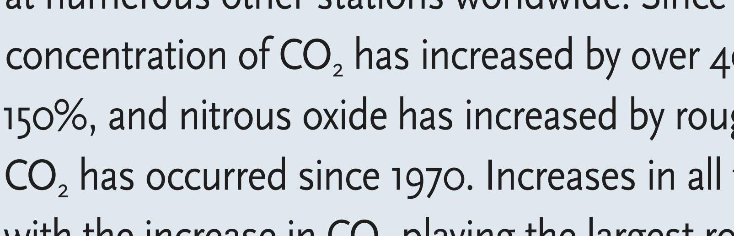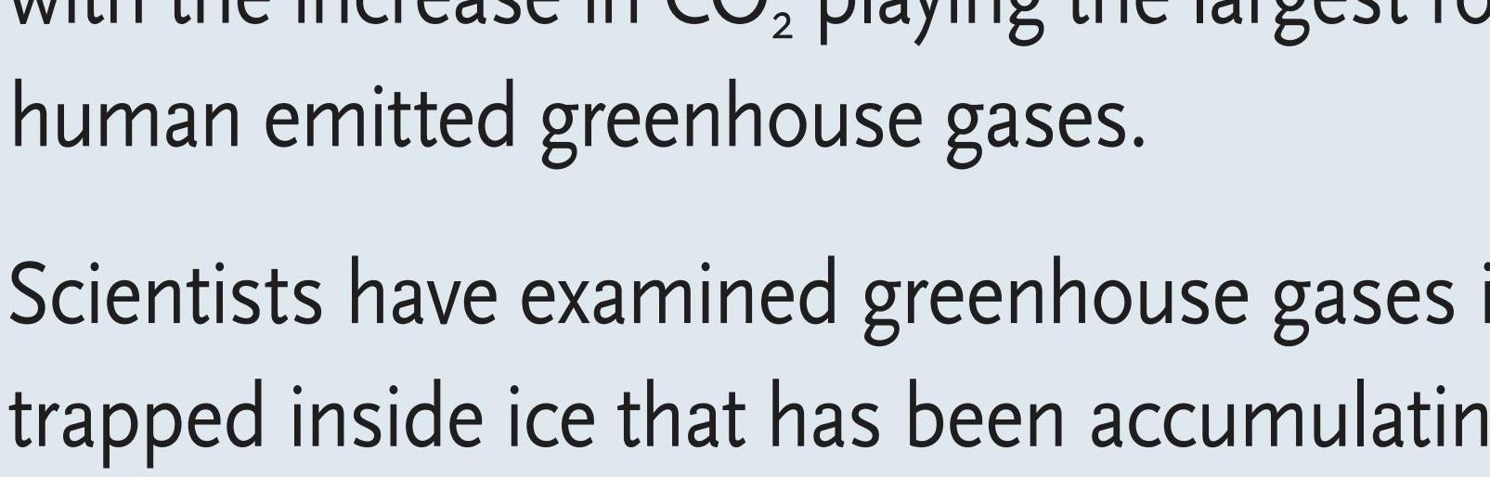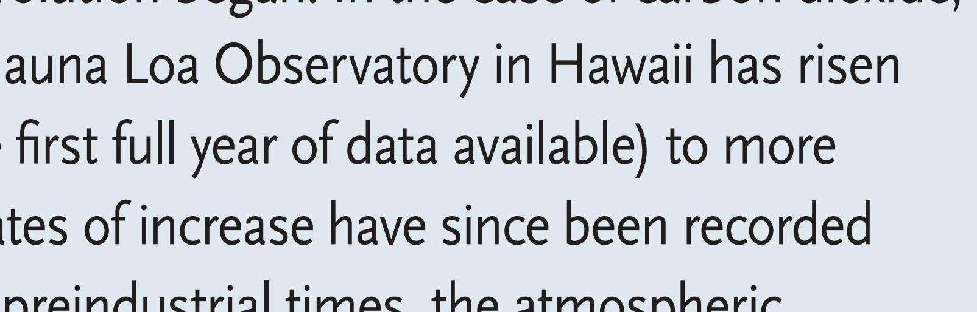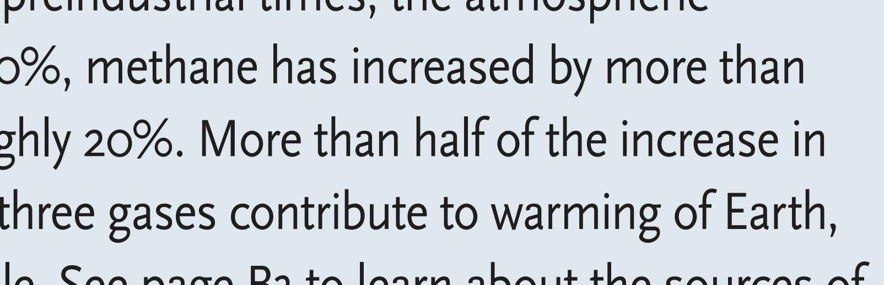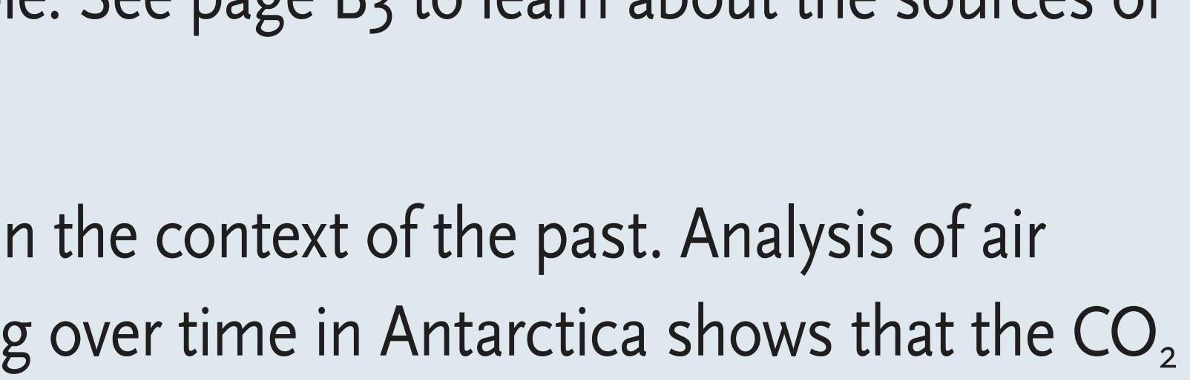

atmospheric CO

starting in the late

2

th

19

century. Modern atmospheric

measurements from Mauna Loa are

superimposed in gray. Source: ﬁgure

Halocarbons, including chloro-

by Eric Wolff, data from Etheridge et al.,

ﬂuorocarbons (CFCs), are chem-

1996; MacFarling Meure et al., 2006;

Scripps CO2 Program.

Learn about the sources of human-emitted greenhouse gases:

■

Carbon dioxide (CO

) has both

■

Methane (CH

) has both human

tions have risen primarily because

■

2

4

natural and human sources, but

and natural sources, and levels

of agricultural activities such as the

CO

levels are increasing primarily

have risen signiﬁcantly since

icals used as refrigerants and ﬁre

use of nitrogen-based fertilisers and

2

because of the combustion of fossil

pre-industrial times due to human

retardants. In addition to being

land use changes.

fuels, cement production, defor-

activities such as raising livestock,

potent greenhouse gases, CFCs

estation (which reduces the CO

growing paddy rice, ﬁlling landﬁlls,

also damage the ozone layer. The

2

taken up by trees and increases the

and using natural gas (which is

production of most CFCs has now

CO

released by decomposition of

mostly CH

, some of which may

been banned, so their impact is

2

4

the detritus), and other land use

be released when it is extracted,

starting to decline. However, many

changes. Increases in CO

are the

transported, and used).

CFC replacements are also potent

2

single largest contributor to global

greenhouse gases and their concen-

■

Nitrous oxide (N

O) concentra-

2

warming.

trations and the concentrations

of other halocarbons continue to

increase.

(red squares), show a sharp rise in

ice core extracted from Antarctica

from analysis of air trapped in an

the past 1,000 years, obtained

2

CO

variations during

Figure B.

